- The Truth table
A | B | C | D | Buttons | CW | ACW | L | R | U | D
0 | 0 | 0 | 0 |  | 0 | 0 | 0 | 0 | 0 | 0
0 | 0 | 0 | 1 |  | 0 | 0 | 1 | 0 | 0 | 0
0 | 0 | 1 | 0 |  | 0 | 1 | 0 | 0 | 0 | 0
0 | 0 | 1 | 1 |  | 0 | 0 | 0 | 1 | 0 | 0
0 | 1 | 0 | 0 |  | 1 | 0 | 0 | 0 | 0 | 0
0 | 1 | 0 | 1 |  | 0 | 0 | 0 | 0 | 0 | 1
0 | 1 | 1 | 0 |  | 0 | 0 | 0 | 0 | 1 | 0
0 | 1 | 1 | 1 |  | 0 | 1 | 1 | 0 | 0 | 0
1 | 0 | 0 | 0 |  | 1 | 0 | 1 | 0 | 0 | 0
1 | 0 | 0 | 1 |  | 0 | 1 | 0 | 1 | 0 | 0
1 | 0 | 1 | 0 |  | 1 | 0 | 0 | 1 | 0 | 0
1 | 0 | 1 | 1 |  | 0 | 1 | 0 | 0 | 0 | 1
1 | 1 | 0 | 0 |  | 0 | 1 | 0 | 0 | 1 | 0
1 | 1 | 0 | 1 |  | 1 | 0 | 0 | 0 | 0 | 1
1 | 1 | 1 | 0 |  | 1 | 0 | 0 | 0 | 1 | 0
1 | 1 | 1 | 1 |  | 0 | 0 | 0 | 0 | 0 | 0

- CW min terms
    - $CW=\overline{A}B\overline{C}\overline{D}+A\overline{B}\overline{C}\overline{D}+A\overline{B}C\overline{D}+AB\overline{C}D+ABC\overline{D}$
$ACW=\overline{A}\overline{B}C\overline{D}+\overline{A}BCD+A\overline{B}\overline{C}D+A\overline{B}CD+AB\overline{C}\overline{D}$
$L=\overline{A}\overline{B}\overline{C}D+\overline{A}BCD+A\overline{B}\overline{C}D$
$R=\overline{A}\overline{B}CD+A\overline{B}\overline{C}D+A\overline{B}C\overline{D}$
$U=\overline{A}BC\overline{D}+AB\overline{C}\overline{D}+ABC\overline{D}$
$D=\overline{A}B\overline{C}D+A\overline{B}CD+AB\overline{C}D$
    - $CW=\overline{C}\overline{D}\left(A⊕B\right)+AB\left(C⊕D\right)+A\overline{B}C\overline{D}$

- CW circuit
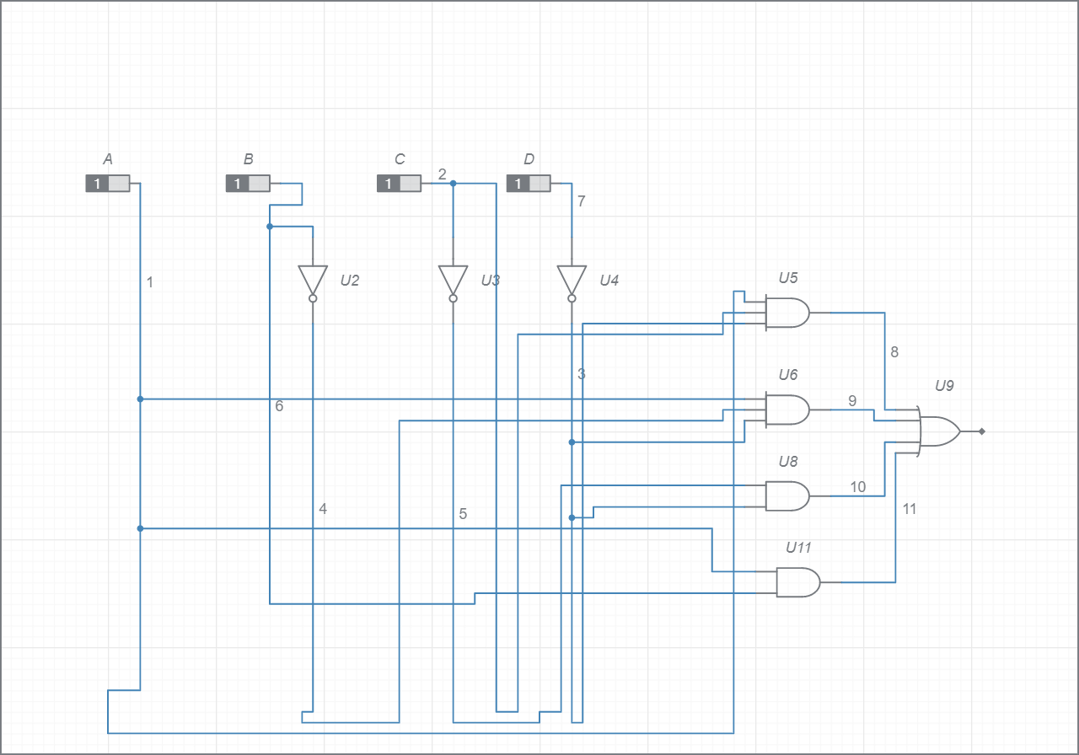

- NAND gate

NOT gate is the NAND gate with shorted inputs
AND Gate is made up of two NAND gates
OR gate is made up not gates and NAND GATES
DE Morgan theorem
$\overline{A}+\overline{B}=\overline{A.B}$

$\overline{A+B}=\overline{A}⋅\overline{B}$
Therefore, the reduced K map result could be represented using NAND gates as follows:

$$CW=\overline{A}B\overline{C}\overline{D}+A\overline{B}\overline{C}\overline{D}+A\overline{B}C\overline{D}+AB\overline{C}D+ABC\overline{D}$$
$$CW=\overline{C}\overline{D}(\overline{A}B+A\overline{B})+A\overline{B}C\overline{D}+AB(\overline{C}D+C\overline{D})$$
$$CW=\overline{C}\overline{D}(\overline{\overline{\overline{A}B+A\overline{B}}})+A\overline{B}C\overline{D}+AB(\overline{\overline{\overline{C}D+C\overline{D}}})$$
$$CW=\overline{C}\overline{D}\left(\overline{\overline{\overline{A}B}\overline{A\overline{B}}}\right)+A\overline{B}C\overline{D}+AB\left(\overline{\overline{\overline{C}D}\overline{C\overline{D}}}\right)$$

- NAND gate truth table
A | B | C | D | CW
0 | 0 | 0 | 0 | 0
0 | 0 | 0 | 1 | 0
0 | 0 | 1 | 0 | 0
0 | 0 | 1 | 1 | 0
0 | 1 | 0 | 0 | 1
0 | 1 | 0 | 1 | 0
0 | 1 | 1 | 0 | 0
0 | 1 | 1 | 1 | 0
1 | 0 | 0 | 0 | 1
1 | 0 | 0 | 1 | 0
1 | 0 | 1 | 0 | 1
1 | 0 | 1 | 1 | 0
1 | 1 | 0 | 0 | 0
1 | 1 | 0 | 1 | 1
1 | 1 | 1 | 0 | 1
1 | 1 | 1 | 1 | 0

- NAND gate CW circuit
